IN723 Layer 3 Switching Lab (VIRL)

In this lab we will configure Inter VLAN routing using SVIs on S1. In addition we will configure a routed port on S1 that is directly connected to R1. This L3 link will be configured for RIP to advertise R1’s loopbacks and S2’s SVIs.
In addition we are using this lab to familiarize ourselves with VIRL which we will use extensively throughout the course.
There are no end user PCs in this lab as they are resource intensive.

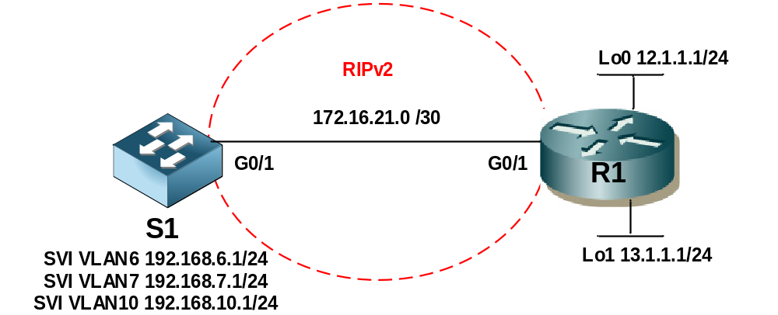
IP Addressing
Interface | IP Address | Notes
S1 G0/1 | 172.16.21.1/30 | Routed port
S1 VLAN 6 | 192.168.6.1/24 | SVI – default GW for VLAN6
S1 VLAN 7 | 192.168.7.1/24 | SVI – default GW for VLAN7
S1 VLAN 10 | 192.168.10.1/24 | SVI – default GW for VLAN10
R1 G0/1 | 172.16.21.2/30
R1 Lo0 | 12.1.1.1/24 | Simulated Network
R1 Lo1 | 13.1.1.1/24 | Simulated Network

VLANs
VLAN | Name | Notes
6 | Secure | Data VLAN
7 | Servers | Data VLAN
10 | Native | Native

Step 1 - Physical
- Physically cable the lab as per the above diagram using an IOSvL2 node for S1 & IOSv for R1.

Step 2 – S1
- Configure S1 with the VLANs as per the above table.
- Configure SVIs for VLAN 6, 7 & 10. Ensure correct IP addressing as per the table.
- Configure the port attached to R1 as a routed port with correct IP addressing.
- Configure RIPv2 with no auto-summary and advertises VLAN 6 & 7 networks.

Step 3 – R1
- Configure the port attached to S1 with correct IP addressing and administratively up.
- Configure the Lo0 & Lo1 interfaces & IP addressing.
- Configure RIPv2 with no auto-summary and advertises the Lo0 & Lo1 networks.

Step 4 – Testing
- Confirm the routing tables on S1 & R1 contain expected routing information.
- Perform extended ping from S1 to R1 Lo0 using the VLAN 6 SVI as the source .
- Perform extended ping from S1 to R1 Lo1 using the VLAN 7 SVI as the source .

Extension
- Configure the S1 routed port (G0/1) as a trunk (switchport) and configure the router for router on a stick (ROAST) inter vlan routing. Configure the subinterfaces with IP addresses within the same ranges as the SVIs.
- The SVIs should be able to ping the router sub interfaces for each corresponding VLAN.

Extension 2
- Configure a new lab using just 2 switches. Cable 4 physical links between them. Configure the links in a single layer 3 etherchannel on each switch. Use the 172.16.1.0/30 network for the link. Ensure you can ping across the link.
- Optional: configure RIP on each switch across the channel, create and advertise a loopback with an IP on your choice on each switch. Ensure the loopbacks can ping each other.

